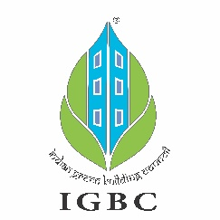
Project Information Form

Renewal of IGBC Green Building Certification

General Project Information
Project Name:
Site Address:
Project Details
Building Type:
Site Area:
Total Built-up Area (excluding Parking Area):
IGBC Project Registration Number (issued earlier):
IGBC Certification Level (awarded earlier):
IGBC Certification Month & Year (awarded earlier):

Pls attach the soft copy / picture of IGBC plaque & certificate (awarded earlier)
Primary Contact details
(key official who belongs to the Parent Organisation / Project Owner)
Name:
Designation:
Parent Organization:
Mobile Number:
Email ID:
Is the Parent Organisation an IGBC Member? If yes, please share Membership No:
Green Building Consultant - Contact Information
Name:
Organization:
Mobile Number:
Email ID:

In order to raise the invoice against the recertification fee to be deposited, please share the following information:
- Name of the Organisation (as you wish to appear in the invoice):

- Organisation’s GST No:

- Organisation's address with PIN code:

===================================================
The aforesaid particulars furnished are correct and true to the best of my knowledge and belief.

____________________________
Signature with official stamp

Name of signatory:
Designation:
Organisation:
Date:

Note: Please fill and submit this form to Mr P V Murthy ( p.v.murthy@cii.in ) with a copy to ritabrata.sen@cii.in . IGBC team would revert by sharing the proforma invoice for payment of recertification fee.

